**42.How to detect outliers in independent variable using seaborn library in python?**

**Objective:**

* To detect outliers in a input variable(X) using python.

**Process:**

* Import library functions.
* Read the data set.
* Use sns.boxplot() from seaborn library.
* Pass the input variable to the ().

**Input:**

* Data set(CSV file).

**Output:**

* Single variable box plot representation.
* Multi variable box plot representation.

**Source code:**

#Single variable box plot

#import library functions

import seaborn as sns

import pandas as pd

#Read the data set

data=pd.read_csv('/home/soft27/soft27/Sathish/Pythonfiles/Employee.csv')

#create data frame

df=pd.DataFrame(data)

#use box plot functions

sns.boxplot(df['age'])

sns.despine()

#Multi variable box plot

#import library functions

import seaborn as sns

import pandas as pd

#Read the data set

data=pd.read_csv('/home/soft27/soft27/Sathish/Pythonfiles/Employee.csv')

#create data frame

df=pd.DataFrame(data)

#use box plot functions

sns.boxplot(df['age'],df['salary'])

sns.despine()

**Screen shots:**

**Output for single variable:**

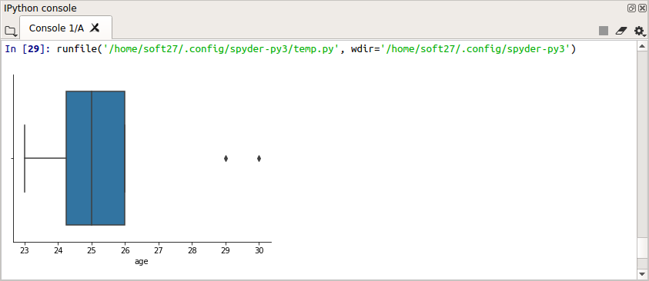

**Output for multi variables:**

